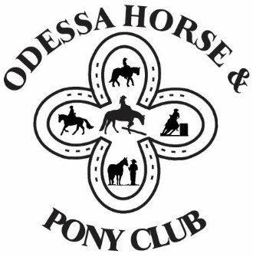
ODESSA HORSE & PONY CLUB
Sponsorship Form 2026
How does sponsoring our club benefit you:
All sponsors are mentioned at our shows and advertised on our website, Facebook and Instagram.
Please include your business card or other graphic for advertising.
Additional benefits:
___ BRONZE $50 - $99............ Your business name on one or more awards.

___ SILVER $100 - $199........... All of the above + your business card or other promotional material will be
available at shows.

___ GOLD $200 - $499............ All of the above + your business banner displayed at shows + a link to your
website on our Sponsor page.

___ PLATINUM $500 -$999...... All of the above + your business receives 2 complimentary tickets to our
Banquet + your business mentioned multiple times at shows.

___ PLATINUM PLUS $1,000+.. All of the above + your business advertised on the main page of our website.
All sponsors are invited to join us at the Year End Banquet, where their contributions will be recognized.
Would you be interested in attending? ___ Yes ___ No
Business and Sponsor’s Name: _________________________________________________________________
Address: __________________________________________________________________________________
Email & Website: ___________________________________________________________________________
Description of your business (to be used for advertising): ____________________________________________
__________________________________________________________________________________________
Please make cheques payable to: Odessa Horse & Pony Club
MAIL form & cheque to: Jacqueline Cote, 820 Road 1, Napanee, ON, K7R 3K7.
OR EMAIL form & etransfer to: odessahpc@gmail.com
THANK YOU VERY MUCH FOR YOUR SPONSORSHIP!!

